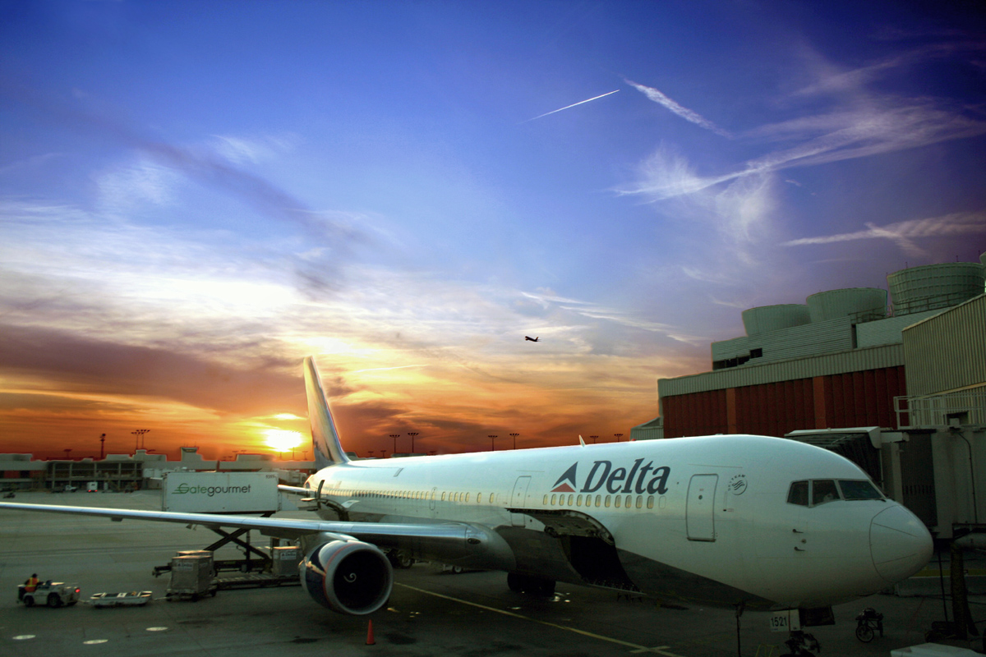

Nathan Holdridge

Reversing The Fate of the Airline Industry

Vivamus

[Street Address][City], [State][Postal Code]  
Phone: [Your Phone]Fax: [Your Fax]  
E-Mail: [Your E-Mail]Web: [Web Address]

[Insert Date]

Nathan Holdridge

Nathan

From the beginning commercial aviation was a shaky business. In fact many of the original airlines didn't want to begin offering passenger routes because it made more sense economically for the airlines to transport cargo than people. Many of the original airlines that tried to pioneer commercial air travel went bankrupt in the process. Back in the 1920’s a large percentage of the population was still afraid to fly. At this time planes still crashed about as often as cars, however this was not the real problem. What really scared people away from flying was the turbulence. The aircraft of the time could not nearly as high as the ones that we have today and the main difference was that rather than occasionally hitting turbulence during takeoff and landing passengers were exposed to turbulence nearly the whole fight. This coupled with more frequent crashes made many people scared to fly. As technology began to advance planes were able fly higher and became significantly safer to travel in. With these advancements flying became increasingly popular in the United States. It was at this time that flying passengers on scheduled flights began to become somewhat plausible for some of the major American airlines. Even in that time commercial flying was difficult. However it is at this time that most of the airlines we still fly today began to emerge. Airlines such as American, Delta, United, Continental, TWA, and Pan American all came onto the scene as the major commercial airlines. Although they it may seem that theses airlines have been successful they have all struggled immensely, especially in the last 20 years.

Looking at the Past

Over the past twenty years the airline industry has struggled significantly. Despite what many customers see as continually rising prices most airlines can not seem to make it out of the red. Some people point to rising fuel costs as the problem. Others point to the heavy taxation and government regulations put on the airlines. Even those who run the airlines admit that it is a near impossible industry. Even C.R. Smith who was the president of American Airlines in the 60’s knew that the business he was in was tough. When asked about commercial aviation he stated, “The economics of it represent sheer hell,”(C.R. Smith). The Airline industry is an extremely tough business to make money in. In fact, since the dawn of commercial aviation if all of the earnings and losses of airlines are combined the American airline industry hasn't made a dime. (Warren Buffett). Despite its economic challenges it is possible to make money in the airline industry, Southwest Airlines is proof of that. With Southwest as evidence that the impossible can be done, what can be done to ensure that airlines are successful in the next 20 years.

# Intro

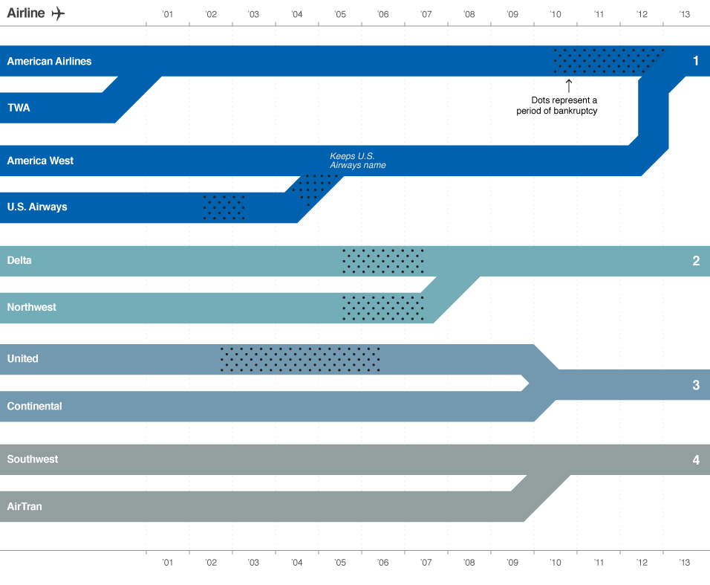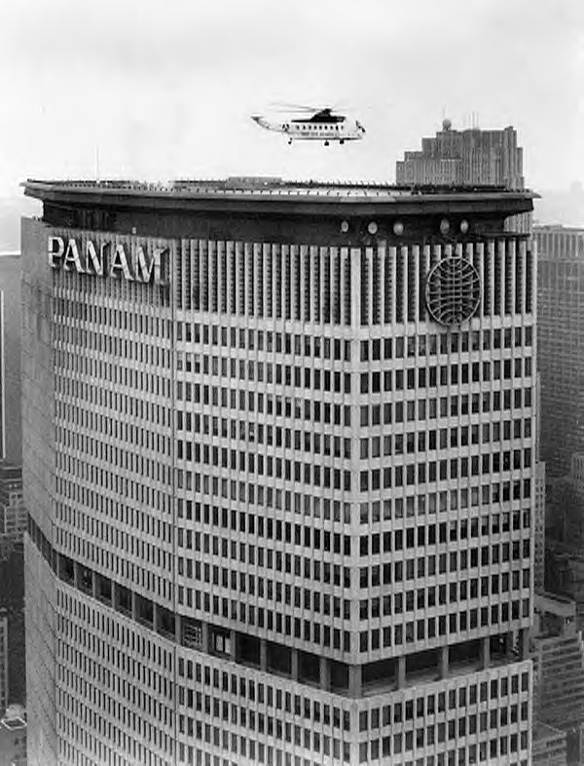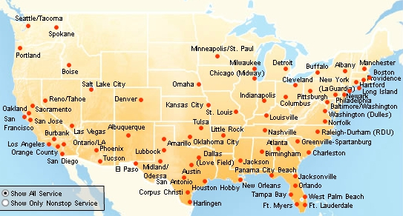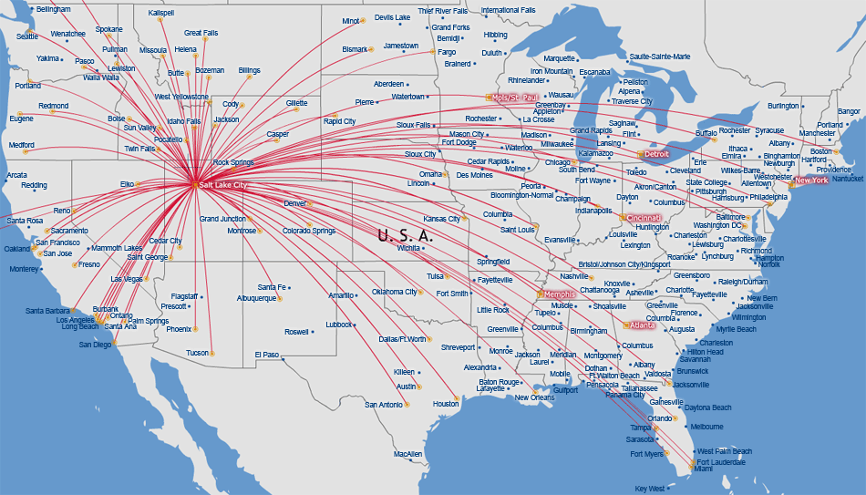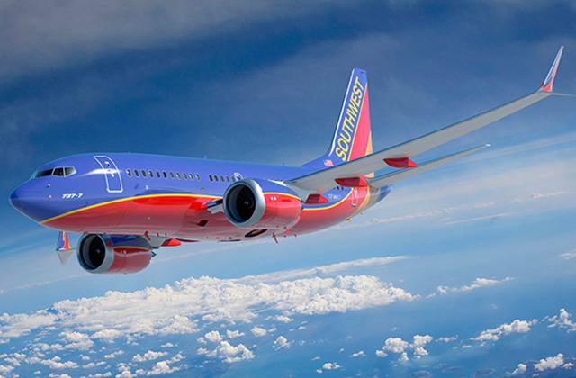

Many people today point to the rising fuel costs as the reason that many of the Airlines are struggling today. However this is not necessarily the case while rising fuel costs have certainly not helped airlines become more profitable it is not really the thing that is hurting them. In fact it is hard to pin down one specific thing that is hurting the airline Industry the most today.

How Airlines Have Dealt With Challenges in the Past

Image shows how airline have merged to create the four major airlines that we know today. (Note: Southwest bought AirTran Airways)(Note: An area of the line with dots represents a period of bankruptcy)

Pan American and TWA have both shut down, American merged with US Airways, and United and Continental merged. Even the airlines who have been in the business from the beginning have struggled. The recent years have brought about the struggles that most of us today are more familiar with, however there was a time back when the airline industry was moving towards de-regulation that caused the collapse of Pan American Airlines.

Many of the airlines that are currently struggling have accumulated a huge amount of debt, some airlines as much as 25 billion dollars (C.A.P.A. Centre for Aviation). With debt a large amount of debt like that it is often impossible for airlines to ever escape from the debt because the price of the interest on the debt alone is hard for them to pay. In order to ever be able to get rid of the debt the airline would have to generate revenue that is not possible for airlines. When airlines debt gets to this point the best option most of the time is for the airlines to file for bankruptcy and more specifically chapter 11 bankruptcy.

About 70 years ago when the airline industry was deregulated it flipped the Airline industry upside down overnight. Airlines went from having routes given to them at the discretion of the government to being able to fly any routes that they wanted. With the deregulation some airlines like Pan American struggled severely however others like Trans World Airways and American Airlines took off. What was different? How could the same piece of legislation help some companies while cripple others? The answer lies in how the companies responded to the change. TWA and American took advantage of the deregulation and added hundreds of new routes domestically and internationally, however Pan Am added few domestic routes to compliment its already strong international empire. Pan Am was unable to add lots of new domestic routes due to a lack of planes fit for these routes and a shortage of cash to get new aircraft. The result was a failing Pan Am and newly successful TWA and American. In conclusion pointing to one specific thing that is supposedly destroying the airline industry is not logical. Whether or not a change, such as rising fuel costs or deregulation, helps or hurts an airline is dependent upon how that change or problem is dealt with. As Allen Blue the co-founder of LinkedIn said, “Where others see problems, I see opportunity” (Allen Blue).

Bankruptcy: What it is and what it does for Airlines

Chapter 11 bankruptcy is a way for companies to seek government protection from their debtors. Chapter 11 bankruptcy has been used by many business to help relieve their companies debt. The process of bankruptcy begins with an airline petitioning to the court for a bankruptcy case; in most cases the court grants this request. In most cases during the case the company will run as normal however in some cases the court will appoint a trustee to run the company while it goes through the bankruptcy process. After the petition is approved the company has four moths to propose a reorganization plan to the court however if more time to complete the proposition is necessary the company can petition to the court for more time and may be awarded up to fourteen more months to prepare their plan for reorganization. The court also has the power to shorten the four-month period if necessary. Once the plan is presented to the court the creditors then get a chance to review the proposition and offer a proposition of their own, or dismiss the case all together. However dismissing the case is unlikely because this often means the debtor will default on their loans, while this means the company would close down it would also mean that the creditors would get no money. Therefore most times the creditors will work with the company and court to try to get a portion of their money back. The proposition is essentially a contract between the debtor and its creditors stating how it will pay back the money as well as setting up a time frame for payments. In most cases the debtors will be receiving pennies on the dollar for what the company owes them. At this time the court reviews the reorganization plan to see first if it is feasible. If the court decides that the plan presents reasonable goals that the company can achieve it then looks to make sure the plan is in the best interest of the creditors in other word the court makes sure that the court believes that this is way that gives the most money possible back to the creditors. This assures that chapter 11 bankruptcy is a last resort for failing companies and not a legal way for companies get rid of unwanted debts. If the court decides that the reorganization is in the best interest of the creditors it looks at one last thing before it will approve the plan. The court must now check that the plan is “fair and equitably” this means that the company must have a plan to pay back to the debtors more than their assets are worth. This final clause assures that having the debtor file for bankruptcy is better for the creditors than shutting down the company and selling the company's assets. If the court decides that the plan meets all of the criteria listed above it will approve the proposal, and the company will reorganize immediately and begin to make the mandatory payments monitored by the court. If the company is not faithful in making its arranged payments the company defaults and will be shut down by the creditors. Companies successfully reorganize from chapter 11 bankruptcy less than 15% of the time (Chapter 11 Bankruptcy: An Overview). However, this strenuous process is often the best option for airlines.

Delta airlines began the Bankruptcy process in 2004 and it effectively saved their company. Delta is an example of how an airline can use the bankruptcy law to reorganize successfully and become profitable once again. When delta filed for bankruptcy it was in more than 25 billion dollars of debt. Today Delta has less that 3.5 million dollars of non equitable debt. Just over 10 years ago Delta Airlines was frantically attempting to restructure itself in order to avoid bankruptcy. Delta was forced release hundreds of employees and added more than 100 flights out of Atlanta while cutting operations out of other hubs by up to 26%. The attempt to avoid bankruptcy by shifting focus to the airline’s home city of Atlanta wasn't successful and in one last desperate move Delta executives sold Delta Connection to SkyWest Airlines for a meager 425 million dollars. Today experts estimate that the worth of Delta connection was between 700 and 800 million dollars. However, with the airline nearly 30 billion dollars in debt the sale was a last ditch effort to keep the airline running. Unfortunately, not even the sale of Delta connection could keep the deeply indebted airline out of bankruptcy and on August 15, 2005 Delta airlines filed for chapter 11 bankruptcy. Delta presented a reconstruction proposal that feature aggressive cuts to spending including a 9% pay cut to all Delta employees and a 14% pay cut for pilots, Delta’s CEO also took a 25% pay cut. In addition delta let nearly 9,000 employees go. With these massive cuts and new focus Delta predicted that it would become profitable again in 2007, and at the end of 2007 Delta was finally making a profit again. Delta was aided by a generous bankruptcy court however the airline still made the tough cuts to become profitable again. Nonetheless how Delta re-organized after bankruptcy to become profitable once again, and also how they eliminated there debt is still extremely remarkable. The way Delta handled bankruptcy should be a model for any airline that must undergo bankruptcy.

Delta’s Remarkable Bankruptcy Story

Often the courts are very lenient with airlines. Bankruptcy still isn't a perfect plan for airlines. Pan American Airlines filed for chapter 11 bankruptcy and was approved however the plan presented was not executed and the airline was shut down on December 4th 1991(*Death of an American Dream- The Pan Am Story*).

Through some of the toughest times for the airline industry one airline has constantly been profitable even while its competitors has been piling up debt and falling into bankruptcy. The airline I am speaking of is, of course, Southwest Airlines. The once small regional airline that stared out with just three aircraft has blossomed into the second largest American airline. How has a company like southwest grown exponentially in a time where airlines are shutting down instead of growing? The key to Southwest's success lies in the brilliant simplicity of Southwest’s business model. Everything Southwest does is laser focused (The Secret to Southwest's Success). Southwest seeks to provide low fares for passengers traveling from major city to major city. If you are trying to book a flight from the airport in Colorado Springs to Chicago southwest is not the way to go as they don’t even operate out of that airport however you will that all three of the major airlines do. Why is this important because Southwest sticks to what it knows. Southwest is not going to fly out of a small airport like Colorado Springs where there is a lower demand for flights, and a need for smaller aircraft due to smaller runways. Rather than go through all the hassle and extra expenses that its competitors do to fly out of both Denver and Colorado springs, Southwest is willing to fly only into Denver and undercut its competitors costs out of that airport by more than $100 on nearly every flight. (Orbitz.com)

Southwest’s Amazing Success

Bankruptcy is a through route for any business to take, as it is only successful 15% of the time. However in the case of the airline industry where many airlines are in billions of dollars in debt it is one of the best options to help an airline eliminate debt and reorganize in a new and more profitable way. Airlines should not try to enter bankruptcy simply to try to eliminate debt, however most airlines today have a crippling amount debt. It is in these cases that airlines should enter bankruptcy to eliminate their debts and reorganize in way that will make them profitable once more.

Bankruptcy Conclusion

The Images above show how few destinations Southwest has in reaction to its commuters. While this may seem like a bad thing it actually plays a vital role in Southwest’s success (Southwest’s Seven Secrets for Success).

Southwest’s business plan is all based upon simplicity. For every new destination that an airline adds there is a whole list of costs associated. These costs are extensive, as the airline has to pay for gates, check in counters, a place for passengers to check luggage, in addition the airline also has to hire a ground crew for the new airport. The Airline will also have to buy more equipment witch will be necessary for them to operate out of this new airport, such as luggage carts and push back carts, these are only some of the costs associated with adding a new destination. Southwest has way fewer destinations and therefore doesn’t pay

The image (right) shows all of Delta Airline’s destinations that can be reached in direct flights out of Denver.

(Note: the image does not show all of Delta Airlines destinations)

The image (left) shows all of Southwest Airline’s destinations

The Boeing 737 is an amazing aircraft and Southwest has taken full advantage of its potential. Southwest Airlines flies only one type of aircraft and this has multiple upsides. First, flying only one aircraft means Southwest only needs to train pilots to fly on type of airplane. While its competitors have to train pilots to fly several different types of aircraft. This also means that any crew can fly any plane, witch means that if necessary Southwest can easily adjust crews and aircraft schedules to keep their flights on time. Southwest doesn’t have to wait for the crew that’s flying in on a delayed flight form Seattle to come fly a flight out of Denver because any crew Southwest employs can take that route if need be. While other airlines would have to wait because that is the only crew that can fly the type of aircraft that is waiting. Secondly, it helps keep maintenance costs down because Southwest only has to train its mechanics how to fix one type of plane. Also they only have to order replacement parts for one type of plane. Maintenance is an expensive task in more ways than one. Firstly, every part that needs to be replaced is expensive so having lots of extra parts is not a viable option. However, every minute that the plane requiring maintenance is not in the air the airline is effectively losing money on it. Having only one type of airplane means Southwest only has to order parts for one type of aircraft. Therefore, they can afford to have more extra parts lying around because they

nearly as much as its competitors for use of airports. Despite having way fewer destinations Southwest doesn’t miss out as much on as many passengers as one would think because Southwest still flies to almost every major city. This means that Southwest still gets the majority of travelers to fly with them while significantly reducing costs. Another way Southwest sticks to its business plan is by not offering a lot of in air services. If you fly Southwest you will get a free drink and some peanuts and possibly crackers, yet you wont be able to order meals or any type of adult beverage. Once again the simplicity of not trying to run a restaurant as well as an airline helps Southwest to keep things simple and intern keep their costs down. While your options may be limited on Southwest every option you have is free and this gives customers a feel that Southwest is not trying to squeeze every penny out of them. This feeling is reinforced with Southwest’s famous bags fly free policy. This is also one of the ways Southwest distinguishes itself from other discount fare airlines such as Jet Blue (The secret to Southwest’s Success).

The 737

Planning Ahead

One final way that Southwest gains a competitive edge over it competitors is by fuel hedging. This simply means that when fuel costs are low southwest buys fuel very aggressively and stores it for latter use when fuel costs go up. This plan allows southwest to use its fuel reserves while fuel costs are high, intern this mean that southwest can undersell sell it competitors even more when fuel prices rise. This correlates well with what I spoke of earlier about how airlines deal with challenges. Southwest has devised a way to turn everyone else’s problem into there opportunity. While other airlines struggle with keep fares reasonable with high fuel cost Southwest just sits back and reaps the benefits of planning for the future (Southwest’s Seven Secrets for success).

know the parts will be used. Where as other airlines do not have this advantage because if they order parts for an Airbus it maybe a year before an Airbus needs that part and all that time it is taking up space in there storage while they keep having to order parts for Boeing aircraft and are forced to wait for the parts to come in while their aircraft sit helplessly on the ground. The third upside to flying one type of aircraft is that when an airline buys planes from the manufacturer in bulk they will get a large discount on there planes. While other airlines have to buy lots of different aircraft in small amounts Southwest can order new 737’s in bulk from Boeing and pay much less for the aircraft. The 737 is yet another way that southwest gains a finical edge over is competitors (The Secret to Southwest’s Continued success).

While truing the airline industry around will not be an easy task, it is doable. In order for airlines to be successful in the next 20 years the first thing that must be accomplished is getting the airlines out of debt. In most cases this will have to be done through the process of bankruptcy. While every case is different airlines have had a tremendous example of how to manage through bankruptcy set by Delta Airlines. Using Delta, as their guide Airlines should be able to mange through he difficult proses of bankruptcy restructured and ready to be able to implement a new business plan that will make them successful. Once the debt has been eliminated the airlines need to adopt a simpler business plan. They need to focus on what they are good at. Cutting down on the destinations that they offer service to would be a great place to start. Also all airlines that want to be successful in the next 20 years need to operate using two or less types of aircraft. This like with Southwest will help to ease costs on the airlines in many ways. In addition the airlines will need to do a better job of planning ahead with fuel costs this is the only way that they will be able to stay in business if oil prices continue to rise. Finally, Strong leadership is needed to run the airlines while the points listed above are a good starting point each airline needs good leadership to implement these points in a practical way that works best for the airline at the time. The airline industry wont get fixed overnight however if airlines get out of debt adopt a simpler business plan and plan better for the future, the airline industry has a very good chance to be successful in the next 20 years.

Conclusion

Works Cited

James, George. "C. R. Smith, Pioneer of Aviation As Head of American, Dies at 90." *The New York Times*. The New York Times, 04 Apr. 1990. Web. 03 Dec. 2015

El-Erian, Mohamed A. "The Secret to Southwest's Success." *BloombergView.com*. BloombergView.com, 13 June 2014. Web. 03 Dec. 2015.

"The Secrets of Southwest's Continued Success." *The Economist*. The Economist Newspaper, 18 June 2012. Web. 03 Dec. 2015.

"US Airline Debt Management Part 1: The Big 3 Take Varying Approaches to Balance Sheet Strength." *CAPA*. N.p., 18 Sept. 2015. Web.

"Chapter 11 Bankruptcy: An Overview | Nolo.com." *Nolo.com*. N.p., 2015. Web. 03 Dec. 2015.

"The Runway to the Final Four." *CNNMoney*. Cable News Network, 2015. Web. 03 Dec. 2015.

Gilmore, Glenn. "Gilmore Social Media." *: “Where Others See Problems, I See Opportunity.”*. N.p., n.d. Web. 03 Dec. 2015.

Brancatelli, Joe. "Southwest Airlines' Seven Secrets for Success." *WIRED*. Future Transport, 08 July 2008. Web. 03 Dec. 2015.